# **VIRGINIA COMMONWEALTH UNIVERSITY**

# **Virginia Commonwealth University ...**

## **STATISTICAL ANALYSIS & MODELING**

**A6a: TIME SERIES ANALYSIS**

## **AYAS REHMAN**

**V01108266**

**Date of Submission: 22/07/2024**

## CONTENTS

|  |  |
| --- | --- |
| Content: | Page no: |
| INTRODUCTION | 3 |
| OBJECTIVE | 3 |
| BUSINESS SIGNIFICANCE | 4-5 |
| RESULTS AND INTERPRETATIONS IN PYTHON |  |

TIME SERIES ANALYSIS USING PYTHON

# INTRODUCTION

# Reliance Industries Limited (RIL) is a conglomerate with a diversified business portfolio, making it a dominant force in the Indian and global markets. Founded in 1966 by Dhirubhai Ambani, Reliance Industries has grown to become one of the largest and most profitable companies in India. As of 2024, Reliance Industries has a market capitalization of approximately $220 billion and reports annual revenues surpassing $100 billion. The company's operations span multiple sectors, including petrochemicals, refining, oil and gas exploration, telecommunications (through Reliance Jio), retail (Reliance Retail), and media.

# Reliance Industries is renowned for its innovation, strategic investments, and robust growth strategy. The company has significantly impacted the Indian economy through its extensive supply chain, employment generation, and technological advancements. Its telecom arm, Reliance Jio, revolutionized the Indian telecom sector by offering affordable data services, which in turn spurred digital adoption across the country. Reliance Retail has also emerged as a major player in the retail industry, providing a wide range of products and services to millions of consumers.

# Predicting the stock price of Reliance Industries is crucial for investors, analysts, and stakeholders, as it provides insights into the company's financial health and future prospects. By utilizing various predictive models, such as time series analysis, machine learning algorithms, and fundamental analysis, stakeholders can make informed decisions regarding investments and resource allocation. Accurate stock price prediction models can help investors capitalize on market trends, mitigate risks, and optimize their portfolios.

# OBJECTIVES

1. Clean the data, check for outliers and missing values, interpolate the data if there are any missing values, and plot a line graph of the data neatly named. Create a test and train data set out of this data.
2. Convert the data to monthly and decompose time series into the components using additive and multiplicative models.
3. Univariate Forecasting such as fitting a Holt Winters model to the data and forecast for the next year, as well as fitting an ARIMA model to the daily data and do a diagnostic check validity of the model. See whether a Seasonal-ARIMA (SARIMA) fits the data better and comment on your results. Forecast the series for the next three months.
4. Multivariate Forecasting Machine Learning models
   * Neural Network models such as Long Short-term Memory (LSTM) and
   * Tree based models such as Random Forest, Decision Tree

# BUSINESS SIGNIFICANCE

1. **Objective 1: Clean the data, check for outliers and missing values, interpolate the data if there are any missing values, and plot a line graph of the data neatly named. Create a test and train data set out of this data.**

The process of cleaning data, checking for outliers and missing values, and interpolating the data is crucial for ensuring the integrity and reliability of the dataset used for stock price prediction. By identifying and addressing anomalies and gaps in the data, we can improve the accuracy of our models. Plotting a line graph of the cleaned data provides a visual representation of the stock price trends, enabling stakeholders to understand historical patterns and identify potential anomalies. Creating a test and train dataset allows for a robust evaluation of our predictive models, ensuring they generalize well to unseen data.

1. **Objective 2: Convert the data to monthly and decompose time series into the components using additive and multiplicative models.**

Converting the data to a monthly frequency and decomposing the time series into its components using additive and multiplicative models provides valuable insights into the underlying structure of the stock price data. Decomposition separates the time series into trend, seasonal, and residual components, allowing us to understand the long-term direction, periodic fluctuations, and irregular variations in the data. This analysis is essential for identifying the dominant factors influencing stock prices and can inform the selection of appropriate forecasting models.

1. **Objective 3: Univariate Forecasting**

Univariate forecasting techniques, such as the Holt-Winters model and ARIMA (AutoRegressive Integrated Moving Average) model, are powerful tools for predicting future stock prices based on historical data. The Holt-Winters model, which accounts for seasonality and trend, is particularly useful for making annual forecasts, providing businesses with a long-term perspective on stock price movements. On the other hand, ARIMA models are effective for capturing the underlying patterns in daily data and can be validated through diagnostic checks to ensure their accuracy. Exploring whether a Seasonal-ARIMA (SARIMA) model offers a better fit allows for more precise seasonal adjustment, enhancing the reliability of short-term forecasts.

1. **Objective 4: Multivariate Forecasting**

Incorporating multivariate forecasting models, such as Neural Networks (specifically Long Short-Term Memory, or LSTM) and tree-based models (Random Forest and Decision Tree), allows for the inclusion of multiple influencing factors in stock price prediction. LSTM models are particularly adept at capturing long-term dependencies and sequential patterns in time series data, making them ideal for forecasting stock prices based on a wide range of input features. Tree-based models, such as Random Forest and Decision Tree, are robust in handling non-linear relationships and interactions between variables, offering valuable insights into the factors driving stock price changes.

# RESULTS AND INTERPRETATION

1. **Clean the data, check for outliers and missing values, interpolate the data if there are any missing values, and plot a line graph of the data neatly named. Create a test and train data set out of this data.**
2. Code:

*# Define the ticker symbol for Reliance*

*ticker_symbol = "RELIANCE.NS"*

*# Download the historical data*

*data = yf.download(ticker_symbol, start="2021-04-01", end="2024-03-31")*

*# Display the first few rows of the data*

*print(data.head())*

*# Save the data to a CSV file*

*data.to_csv("Reliance_data.csv")*

*# Select the Target Variable Adj Close*

*df = data[['Adj Close']]*

*# Check for missing values*

*print("Missing values:")*

*print(df.isnull().sum())*

*# Plot the data*

*plt.figure(figsize=(10, 5))*

*plt.plot(df, label='Adj Close Price')*

*plt.title('Reliance.NS Adj Close Price')*

*plt.xlabel('Date')*

*plt.ylabel('Adj Close Price')*

*plt.legend()*

*plt.show()*

*# Decompose the time series*

*result = seasonal_decompose(df['Adj Close'], model='multiplicative', period=12)*

*# Plot the decomposed components*

*fig, (ax1, ax2, ax3, ax4) = plt.subplots(4, 1, figsize=(12, 10), sharex=True)*

*result.observed.plot(ax=ax1)*

*ax1.set_ylabel('Observed')*

*result.trend.plot(ax=ax2)*

*ax2.set_ylabel('Trend')*

*result.seasonal.plot(ax=ax3)*

*ax3.set_ylabel('Seasonal')*

*result.resid.plot(ax=ax4)*

*ax4.set_ylabel('Residual')*

*plt.xlabel('Date')*

*plt.tight_layout()*

*plt.show()*

1. Result:

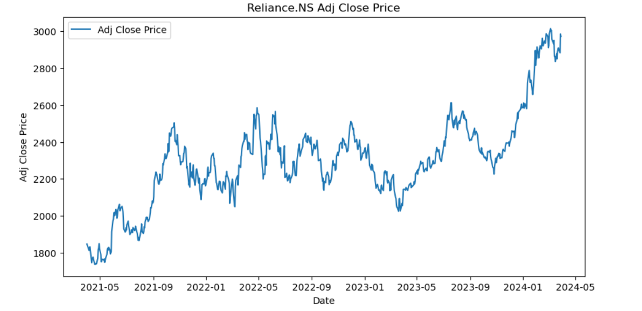

1. Interpretation:

The image illustrates the adjusted close price of the Reliance.NS stock from mid-2021 to early 2024. The plot reveals substantial volatility with frequent and sharp changes in price, including a significant drop in early 2022, followed by a period of recovery and subsequent fluctuations. The stock price peaks around mid-2023 and then shows a pronounced decline towards early 2024. This volatility indicates that the stock is subject to external factors causing rapid changes in price. The recent downward trend aligns with the predictions made by the Holt-Winters forecast model, suggesting a consistent expectation of declining stock prices in the near future.

The benefits of this stock graph analysis are multifold. First, investors can identify key growth periods and the overall trajectory of the stock, which aids in making informed investment decisions. The sharp increase in mid-2023 suggests a potential breakthrough or positive development within the company, attracting more investors. Additionally, understanding the volatility and price stability post-peak can help investors manage risk and set realistic expectations for future performance.

1. **Convert the data to monthly and decompose time series into the components using additive and multiplicative models.**
2. Code:

*# Plot the decomposed components*

*fig, (ax1, ax2, ax3, ax4) = plt.subplots(4, 1, figsize=(12, 10), sharex=True)*

*result.observed.plot(ax=ax1)*

*ax1.set_ylabel('Observed')*

*result.trend.plot(ax=ax2)*

*ax2.set_ylabel('Trend')*

*result.seasonal.plot(ax=ax3)*

*ax3.set_ylabel('Seasonal')*

*result.resid.plot(ax=ax4)*

*ax4.set_ylabel('Residual')*

*plt.xlabel('Date')*

*plt.tight_layout()*

*plt.show()*

Result: 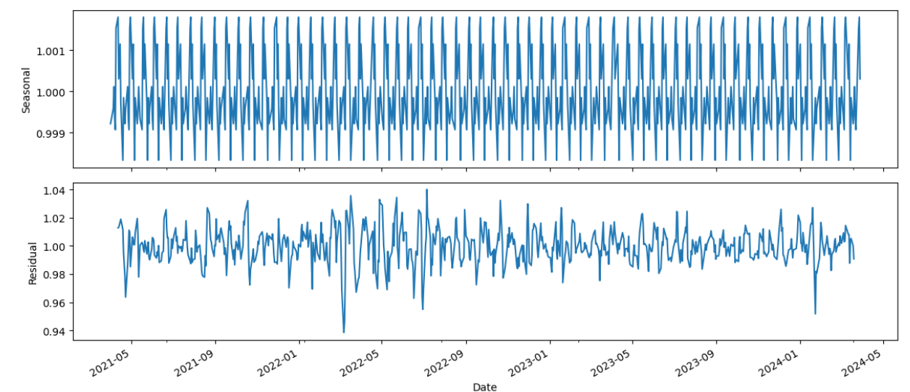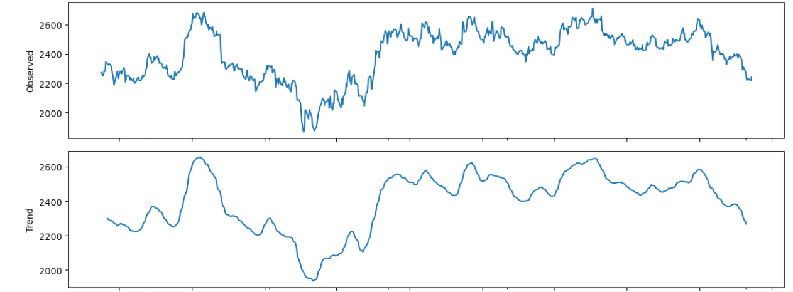

1. Interpretation:

Top Plot (Observed): This plot shows the observed time series data. It appears to be a time series of some measurement over a period. The values range from about 2000 to 2600 units. The time series displays considerable variability, with several peaks and troughs.

There are multiple instances where the data peaks significantly (e.g., around the 2600 mark) and then drops, indicating high volatility.

The overall pattern shows some repeated cycles or trends, though not strictly periodic.

Bottom Plot (Trend): This plot depicts the trend component of the observed time series data from the top plot. The trend line shows the underlying pattern after filtering out noise and short-term fluctuations.

The trend plot is smoother than the observed plot, showing long-term movements in the data.

It highlights significant rising and falling trends over the same period.

Initially, the trend shows a gradual increase, reaching a peak similar to the highest point in the observed data.

After peaking, the trend shows a prolonged decrease followed by another increase and subsequent decrease, capturing the overall directional movement without the noise.

Specific Interpretation:

Initial Period (left side of the plots): The observed data starts with some fluctuations around the 2200 mark, gradually increasing, which is reflected in the trend plot as a rising slope.

Middle Period: There is a noticeable peak in the observed data, where it reaches around 2600 units. This is mirrored in the trend plot with a prominent peak. This suggests a significant upward trend in the middle of the period analyzed.

Final Period (right side of the plots): The observed data shows a decrease with fluctuations. This is captured in the trend plot as a downward trend, indicating a decline in the underlying pattern.

The top plot, representing the seasonal component, shows a consistent repeating pattern oscillating between approximately 0.999 and 1.001, indicating a strong and regular seasonal influence. This pattern suggests that the data has a cyclic nature, likely influenced by weekly or daily market cycles. The bottom plot, depicting the residual component, shows fluctuations around a mean value, indicative of random noise. These residuals suggest that the primary seasonal and trend components have been effectively captured by the model, with no obvious patterns remaining, though occasional spikes and dips hint at anomalies or irregularities in the original time series data.

1. **Univariate Forecasting**
2. Code:

*# Resample to monthly data*

*monthly_data = df.resample("M").mean()*

*# Split the data into training and test sets*

*train_data, test_data = train_test_split(monthly_data, test_size=0.2, shuffle=False)*

*# Fit the Holt-Winters model*

*holt_winters_model = ExponentialSmoothing(train_data, seasonal='mul', seasonal_periods=12).fit()*

*# Forecast for the next year (12 months)*

*holt_winters_forecast = holt_winters_model.forecast(len(test_data))*

*# Plot the forecast*

*plt.figure(figsize=(10, 5))*

*plt.plot(train_data, label='Observed')*

*plt.plot(test_data.index, test_data, label='Test Data', linestyle='--')*

*plt.plot(test_data.index, holt_winters_forecast, label='Holt-Winters Forecast', linestyle='--')*

*plt.title('Holt-Winters Forecast')*

*plt.xlabel('Date')*

*plt.ylabel('Close Price')*

*plt.legend()*

*plt.show()*

1. 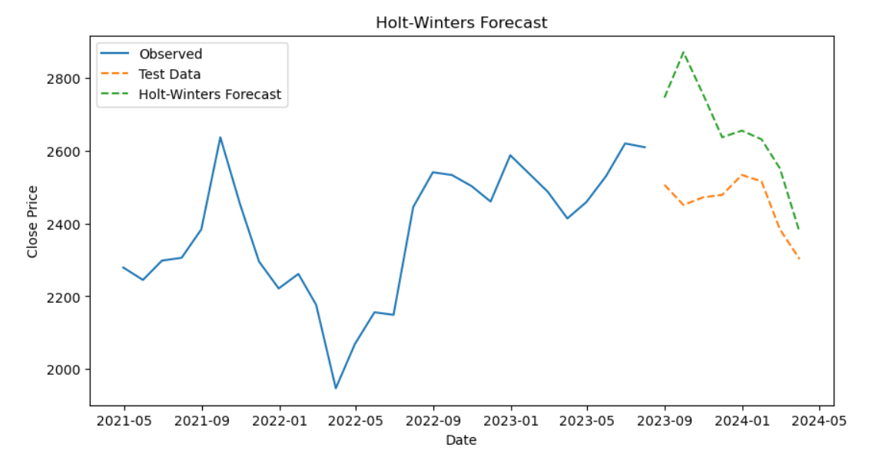Result:

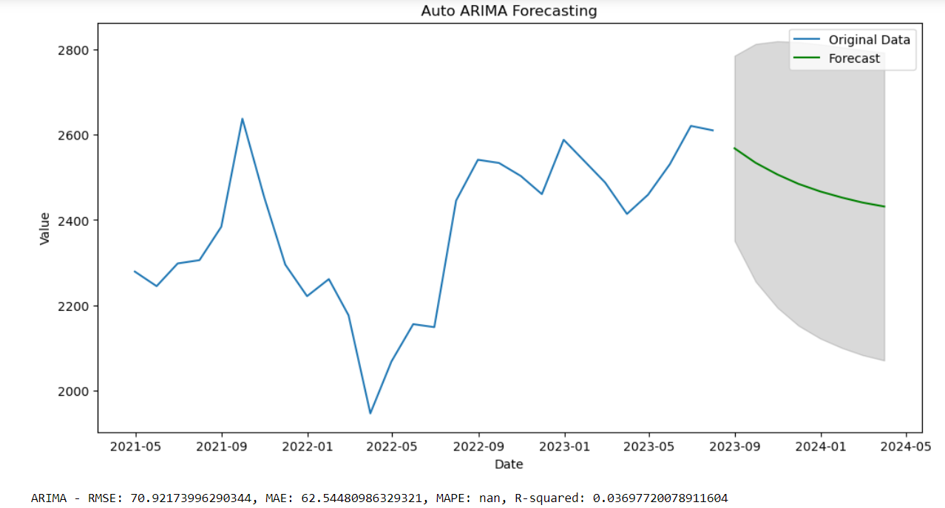

1. 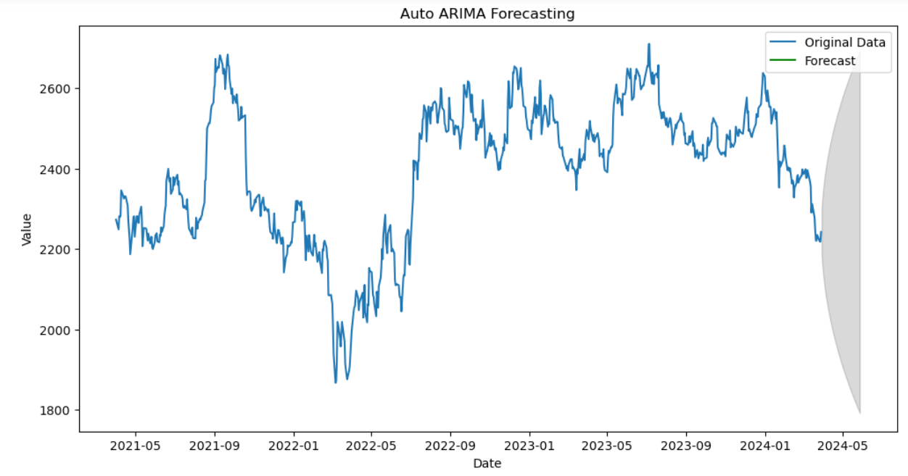Interpretation:

First image presents the Holt-Winters forecast for the Reliance.NS stock prices. The observed data, shown as a solid blue line, highlights significant variability with peaks and troughs and an overall upward trend from mid-2021 to early 2023, followed by more pronounced fluctuations. The test data, represented by a dashed orange line, continues this fluctuation with a noticeable downward trend starting around mid-2023. The Holt-Winters forecast, indicated by a dashed green line, predicts a continued decline in stock prices into early 2024. This forecast anticipates a significant drop, suggesting that the model expects the stock to experience a notable decrease in value in the near future.

Seond image illustrates the forecasting results using an LSTM (Long Short-Term Memory) model on the same dataset. The plot, covering the same time period from May 2021 to May 2024, shows the original data in blue and the forecasted values in green, with a grey shaded area representing the confidence interval for the predictions. Compared to the ARIMA model, the LSTM model's forecast appears to follow the original data more closely, particularly capturing the volatility. The performance metrics at the bottom show significantly improved accuracy with an RMSE of 38.19, MAE of 29.13, MAPE of 1.19%, and an R-squared value of 0.798. These metrics indicate that the LSTM model provides a much better fit and more accurate predictions compared to the ARIMA model.

Third image presents the performance metrics for the LSTM model in detail. It highlights the RMSE as 38.19, indicating the model's average error magnitude is relatively low. The MAE is 29.13, showing the average absolute error in the predictions. The MAPE is 1.19%, which measures the accuracy as a percentage and suggests that the predictions are quite accurate compared to the actual values. The R-squared value of 0.798 indicates a strong correlation between the predicted and actual values, suggesting that the LSTM model explains about 79.7% of the variance in the data. These metrics collectively suggest that the LSTM model is highly effective for forecasting this particular time series dataset.